HOW TO CHANGE FY2025 VOUCHERS AND SC VOUCHERS TO FY2026

If you have a FY2025 voucher or SC voucher (Accounting Date: 09/01/24 through 08/31/25) that needs to be changed to FY2026, you must take the following steps:

Step 1: Go to the Invoice Information page on the voucher.

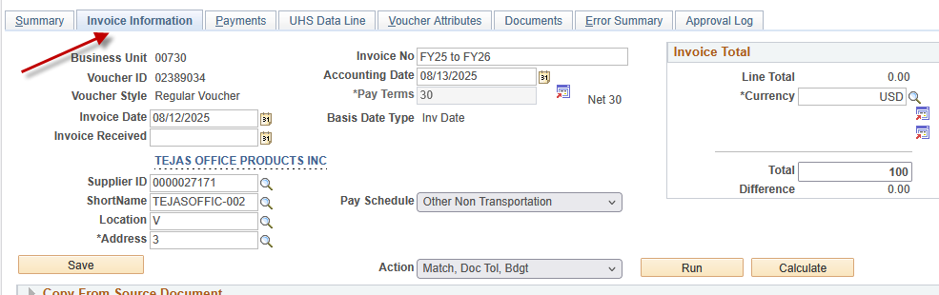

Step 2: Do not change the Accounting Date to FY2026 yet.
Change the voucher gross amount and voucher lines to $0 and save the voucher. Then, re-budget check it with a FY2025 Accounting Date.
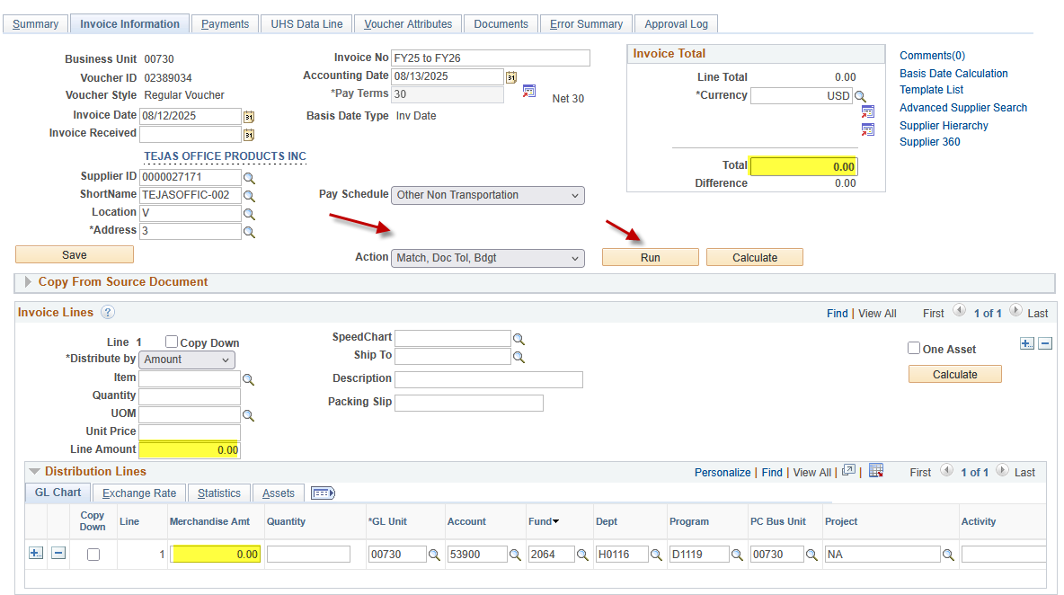

Step 3: Change the Accounting Date and the Scheduled Due Date to FY2026 (09/01/25). Then save the voucher.
On Invoice Information Tab: 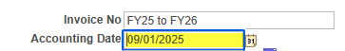

On Payments Tab: 

Step 4: The system displays the following message:

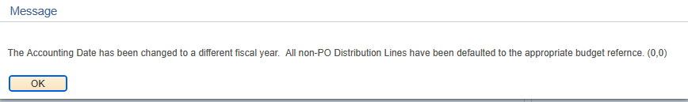

The message indicates the following:
Non-PO Voucher Budget Reference is automatically changed to BP2026.
PO Voucher Budget Reference is not changed because it is tied to the corresponding PO.

Click on .

Now you have a FY2026 voucher. You may enter the voucher gross and voucher line amounts and budget check the voucher.

Voucher Change Due Dates:

Tuesday, August 26, 2025 | 8:00 AM | Departments can begin creating and submitting FY26 vouchers (Accounting Date and Scheduled Due Date equal to or after 09-01-25). However, users cannot create FY25 vouchers for prior-year PO's (BP2024 and earlier) on non-project cost centers until September 1, after the PO Carryforward process is completed.
Friday, August 29, 2025 | 5:00 PM | Deadline for departments to convert all unprocessed FY25 vouchers to FY26 by changing the Accounting Date to 09-01-25 and budget checking the voucher. FY25 vouchers that will not be used should be deleted.

