UH Rocks!
  - A Virtual Field Trip of UH Campus Building Stones
  - Physical Geology – Fall 2025
Name:
myUH ID number:
Professor’s Name:
Class Time:

Academic Honesty (Acknowledgement Required)
The UH Rocks! virtual field trip is to be completed by yourself; you should not work with a partner or group. Do not search for answers online because 1) it is cheating, 2) the posted answers are incorrect, and 3) questions change every semester. It is a violation of UH Academic Honesty Policy to upload any of this material to sites such as Chegg and CourseHero. If you are unfamiliar with a word or geologic concept, looking it up online to find the correct spelling and definition is okay. If you need help, go to the Geoscience Learning Center.
By submitting this work, I, Type Your Name Here attest that I have not violated the UH Academic Honesty code. I completed this assignment by myself and did not copy any portion of my answers from another student, website, or any other source, including AI such as ChatGPT, Microsoft CoPilot, Google Gemini, or Anthropic.

Instructions
The buildings, boulders, and sculptures on the University of Houston campus use many geologic materials. This tour takes you to many stops on campus to learn about them. At each stop, you will need to read about the rocks, look at images, and answer questions.
Each location has a short description of the stone and several photos. There are some 3D montages using photos and LiDAR imaging. Be sure that you click on both the photos and link to the 3D images to see the details of the building stones. The process of combining 2D images to create these 3D images isn’t perfect; so, some of the 3D images have gaps and irregular edges.

Accessing the Trip
This virtual field trip was built in Google Earth. Click here to access the trip. The first page that comes up is a summary of building stones. Use the menu on the bottom left to move between stops. At each location, a box with information about each stop and images will appear on the right side of the screen. Click on the pictures to make them larger.

Written Answers
All answers should be written in complete sentences and typed in the supplied boxes. Your responses will appear in a green-colored font, do not change this. Any answers not written in full sentences will be marked as incorrect and will not receive credit.
Each stop has several questions. Look at the instructions to see how many questions you must answer per stop. You can choose which of the available questions you want to answer. You should have answers for 18 questions for your submission.

Assignment Submission
All virtual field trips are due by Thursday, December 4, 2025. Save your completed Word document as “yourlastname-firstname-UHrocksVFT”. Failure to use this naming convention may result in you not receiving credit. The file size must be less than 100 MB. If you need to reduce your file size, make sure images/annotations are still legible. Submit your completed document using the following form, you must be logged into your @cougarnet.uh.edu Microsoft account. Only Microsoft Word and PDF formats are accepted.
Due Date: Thursday, December 4, 2025
Submission link: https://forms.office.com/r/Zaucpagwq4 (make a separate submission for each VFT you complete)
Teaching Assistants will begin grading submissions after the deadline. After your work is graded, you will receive a confirmation email from a TA. Submissions are graded as pass/fail. If your assignment requires resubmission because of too many incorrect questions, missing answers, or incomplete sentences, you will have 48 hours to do so.
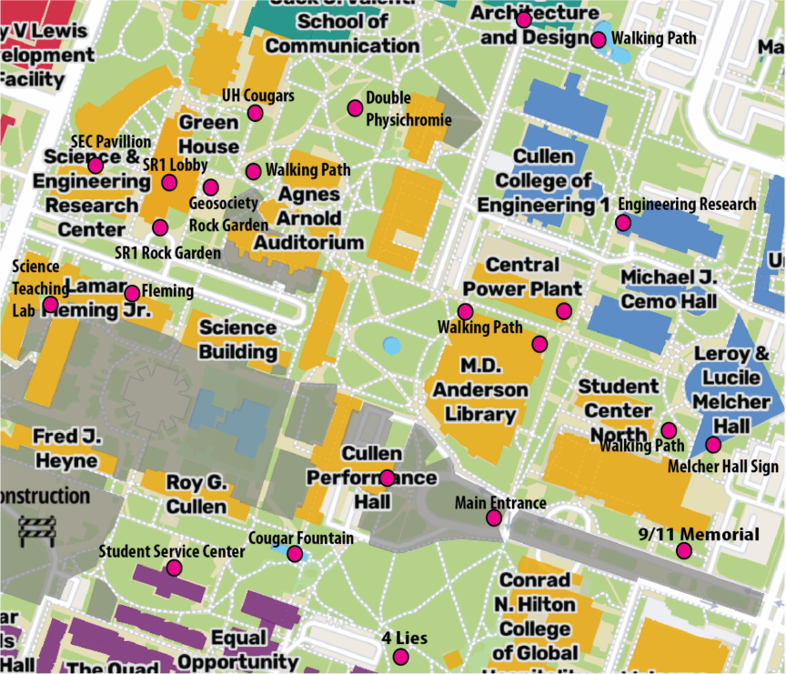
2025 UH Campus Map showing stop locations (pink dots) as well as others with interesting rocks. Gray areas are under construction. So, if you want to see these rocks in-person, some of the stops in this virtual trip may not be accessible during construction.

Introduction Slide
Be sure to read the introduction to the Google Earth trip, it contains important information that can help you answer some questions. Access the trip here.

Stop 1 SR1 Lobby (Answer five of these questions for Stop 1)

Igneous Rock
- Is this rock ultramafic, mafic, intermediate or felsic? How can you tell?

- Is this an intrusive or extrusive igneous rock. Explain.

Sedimentary Rock
- What type of paleoenvironment did this rock form in?

- Would you use this as a building stone? Explain why or why not.

Metamorphic Rock
- Since this rock is mainly composed of calcite, what could you infer was the protolith of this rock?

- Marble is often used for decorative purposes. Do you think it would be good for any other use?

Stop 2 SR1 Mineral Cases (Answer three of these five questions)
This summer, the mineral cases were updated. The changes are mostly cosmetic except we are about to add some UV fluorescent minerals to a case on the second floor.
- After seeing the movie, have you visited the mineral displays? If not, what should we do to make these more cases interesting?

- How did the prehnite form?

- Why did salt originally form with the prehnite?

- What kind of rock are the dinosaur footprints preserved in?

- In what class offered by the EAS department would you learn about minerals?

Stop 4 SR1 Rock Garden (Using the 3D image, answer one of these three questions)
- There are >5 igneous rocks here. Look at this link and describe this igneous rock. Is it intrusive or extrusive?

- There are >5 sedimentary rocks here. Many of these are chemical sedimentary rocks. List these.

- Use this link to see a 3D image of one of the new rocks in the Rock Garden. What type of rock is it? Describe the tectonic environment where it formed.

Stop 5 Fleming Ledge (Answer one of these three questions)
- Is this felsic intrusive or extrusive? Explain your answer.

- How old is this rock?

- What is the name for the black regions in this ledge? Did they form before or after the granite?

Stop 6 Fleming Limestone (Answer one of these three questions)
1. Which fossils are common in this rock?
2. What was the environment this sedimentary rock formed?

3. How would you idenify the minerals in this sedimentary rock?
Stop 8 Cullen Hall Lobby (Answer one of these three questions)
- Why does the marble occur as broken into angular pieces?

- There are several types of relative dating? Which technique is used to determine relative age in this marble?

- Describe the differences and similarities between the marbles here and in the 9/11 Memorial at Stop 16.

Stop 10 Student Service Center Ceiling (Answer one of these three questions)
- Are these stalagmites or stalactites? Why?

- Where would you go in Texas to find an example of a natural stalactite or stalagmite?

- Would you find these anywhere else on campus? Explain your answer.

Stop 11 Student Service Center Ledge (Answer one of these three questions)
- Although the minerals in slate are too small to be seen without a microscope, what platy minerals do you think are present?

- What type of rock was this before it was metamorphosed?

- Along what type of plate boundary would slate most likely form?

Stop 13 Statue of Four Lies (Answer one of these three questions)
- Watch a Youtube video by the two artists as they describe their thoughts about this statue. What would you do to dress up this sculpture?

- How many buildings on campus have you seen with this building stone? List them.

- What type of depositional environment does this limestone represent? What were the water conditions (i.e., temperature, depth, oxygen abundance, etc.) within which these ancient shelly organisms thrived?

Stop 17 Cornerstone Melcher Hall (Answer one of these three questions)
- How is cross-stratification produced?

- Describe the key characteristics of this rock?

- What was the environment of deposition?

Stop 19 Granitic Gneiss and Aplite (Answer one of these three questions)
- Describe the gneiss. Use full sentences.

- Describe the felsic dike. Use full sentences.

- During the 200 million years between metamorphism and intrusion of the dike, what happened to gneiss?

Stop 21 Benches at School of Architecture (Answer one of these three questions)
- Why did the sculptor choose this granite instead of granite found near Fleming?

- Have you tried sitting on these artistic benches? If so, describe your reaction to this art work.

- Do you have a favorite song or artwork similar to this stone bench? Why?

