Virtual Field Trip: Exploring Earth’s Mantle
  - Physical Geology -Fall 2025
Name:
myUH ID number:
Professor’s Name:
Class Time:

Academic Honesty (Acknowledgement Required)
The mantle assignment is to be completed by yourself; you should not work with a partner or group. Do not search for answers on the internet because 1) it is cheating; 2) answers that are posted are incorrect, and we’ll know where you got them from, and; 3) the questions change every semester. If you are unfamiliar with a word or geologic concept, it is okay to look it up online to find the correct spelling and definition. If you find yourself needing help, physical geology teaching assistants staff the Geoscience Learning Center in Fleming 136.
By submitting this work, I, Type Your Name Here attest that I have not violated the UH Academic Honesty code. I completed this assignment by myself and did not copy any portion of my answers from another student, website, or any other source, including AI such as ChatGPT, Microsoft CoPilot, Google Gemini or Anthropic.
If you submit this material to an online learning platform such as Chegg, Course Hero, or any other education technology website, you violate the UH academic honesty policy and our Creative Commons license.

Instructions
Complete the assignment in this document.

Written Answers
All answers should be written in complete sentences and typed in the supplied boxes. Your responses will appear in a red-colored font like this, do not change this. Any answers not written in complete sentences will be marked as incorrect and will not receive credit. Each stop has several questions, and you’ll be able to choose which ones to answer.

Assignment Submission
All virtual field trips are due by Thursday, December 4, 2025. Save your completed Word document as “yourlastname-firstname-MantleVFT”. Failure to use this naming convention may result in you not receiving credit. The file size must be less than 100 MB. If you need to reduce your file size, make sure images/annotations are still legible. Submit your completed document using the following form, you must be logged into your @cougarnet.uh.edu Microsoft account. Only Microsoft Word and PDF formats are accepted.
Due Date: Thursday, December 4, 2025
Submission link: https://forms.office.com/r/Zaucpagwq4 (make a separate submission for each VFT you complete)
Teaching Assistants will begin grading submissions after the deadline. After your work is graded, you will receive a confirmation email from a TA. Submissions are graded as pass/fail. If your assignment requires resubmission because of too many incorrect questions, missing answers, or incomplete sentences, you will have 48 hours to do so.

Preface
Geological field trips are one way to learn about Earth's natural history. Typical tools used on geological field trips include rock hammers, hand lenses, and maps. However, these classic geologic field trips are only possible if the rocks of interest are exposed at Earth’s surface. The vast majority of Earth’s geology is deep beneath our feet, in the Earth’s interior. In this assignment, you will explore Earth’s mantle. The mantle was once thought to be a relatively featureless realm between the crust and core. However, current ideas (see Fig. 1 below) suggest the mantle contains hot, buoyant ‘plumes’ of abnormally hot rock that rise under ‘hotspot chains’ such as Hawaii. Under subduction zones, ancient oceanic crust is inserted and recycled into the mantle, sinking and buckling under its own weight to the core-mantle boundary.
Geophysical techniques such as seismic tomography provide geologists with a window to peer into the 3D structure of the mantle to study present tectonic processes and the geologic past. This exercise will introduce you to mantle tomography, which provides increasingly clearer images of Earth’s interior, similar to CT scans used by medical doctors.
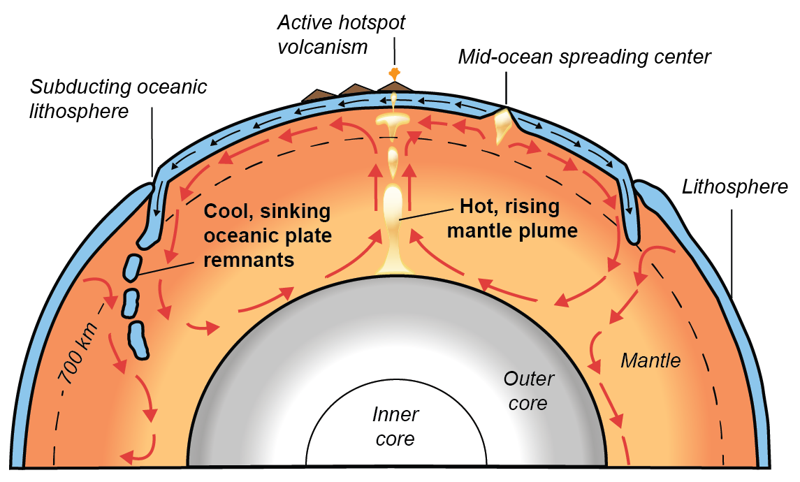
Figure 1 - Earth’s mantle showing possible mantle flows (red arrows). Whole-mantle convection is driven by the sinking of cooler, subducted oceanic lithosphere, and the rising of hot, mantle plumes from the core-mantle boundary (re-drawn from USGS).

Aims
The purpose of this assignment is to make observations of the Earth’s mantle from seismic tomography. Our window into the mantle will be provided by the Hades Underworld Explorer (http://www.atlas-of-the-underworld.org/hades-underworld-explorer/), which was generously built by researcher Dr. Douwe van Hinsbergen of Utrecht University, Netherlands.

Getting Started
Before you begin, let us first review two important terms: cross-sections and seismic tomography. In this assignment, you will look at cross-sections or a view exposed by making a straight cut through an object. For example, Figure 2 below shows a cross-section through an apple. In this exercise, we will look at cross-sections of the Earth. Have another look at Figure 1 (on Page 3). Can you visualize how Figure 1 shows a straight cut through a spherical Earth?

Figure 2 - Cross-section through an apple shown on the right. (Source: Wikipedia https://en.wikipedia.org/wiki/Australian_cuisine)
Obviously, you cannot slice across the entire Earth like an apple. However, seismologists have developed a technique called seismic tomography to image the Earth’s interior. Seismic tomography uses seismic waves from earthquakes to create computer-generated cross-sections of the Earth. The cross-sections are colored by variations in earthquake wave speeds, which can differ by several percent throughout the Earth. Although research continues on the specific reasons for these wave-speed variations, most scientists agree that thermal differences (i.e., hotter or cooler regions) within Earth play the most important role. Hence, in a way, seismic tomography can be understood as a thermal camera image of the Earth. Figure 3 below shows a thermal camera image of two feet that reveals higher temperatures in one foot (left side of the image).
Figure 3 - Figure 3 - Thermal camera imaging of two feet. (Source: https://reductionrevolution.com.au/blogs/news-reviews/thermal-camera-infrared-scanner-uses) | 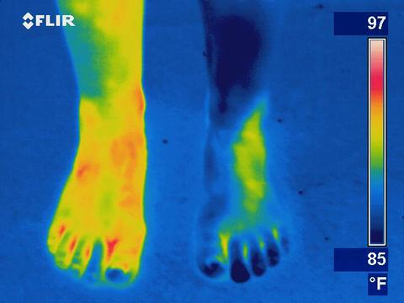

Part 1: A deep dive into the mantle under Kamchatka
The largest earthquake to occur in 2025 (so far) was a Mw 8.8 off the southern coast of Kamchatka. The second-largest, a Mw 7.8, also occurred off Kamchatka. Investigating these earthquakes indicates that they occurred at depths of 35 and 20 km. But, you probably don’t know that tectonic setting in this part of Russia. To investigate this, you will look at seismic tomography of the Earth’s mantle using Hades Underworld Explorer. This tool provides a web interface where you can specify the start and end points of a geologic cross-section through the Earth (from the Earth’s surface to the core-mantle boundary at 2890 km depth). Mantle tomography data is then displayed on the specified cross-section slice. To get started:
- In a web browser, load the Hades Underworld Explorer (http://www.atlas-of-the-underworld.org/hades-underworld-explorer/). Note: Do not use a Firefox browser.
- Navigate to the top right corner of the map window and click on the button entitled “Settings (expand)”.
- Check these two boxes: “Show high contrast image” and “Show plate boundaries”. This will make mantle features clearer. The plate boundaries will help you locate your cross-sections more easily.
On the map interface, navigate Google Maps to drag and move the “L” marker off the west coast of Russia and the “R” marker in the Pacific Ocean. Note: “L” marks the left edge of the section, and “R” marks the right edge. An example is shown in Figure 4 below.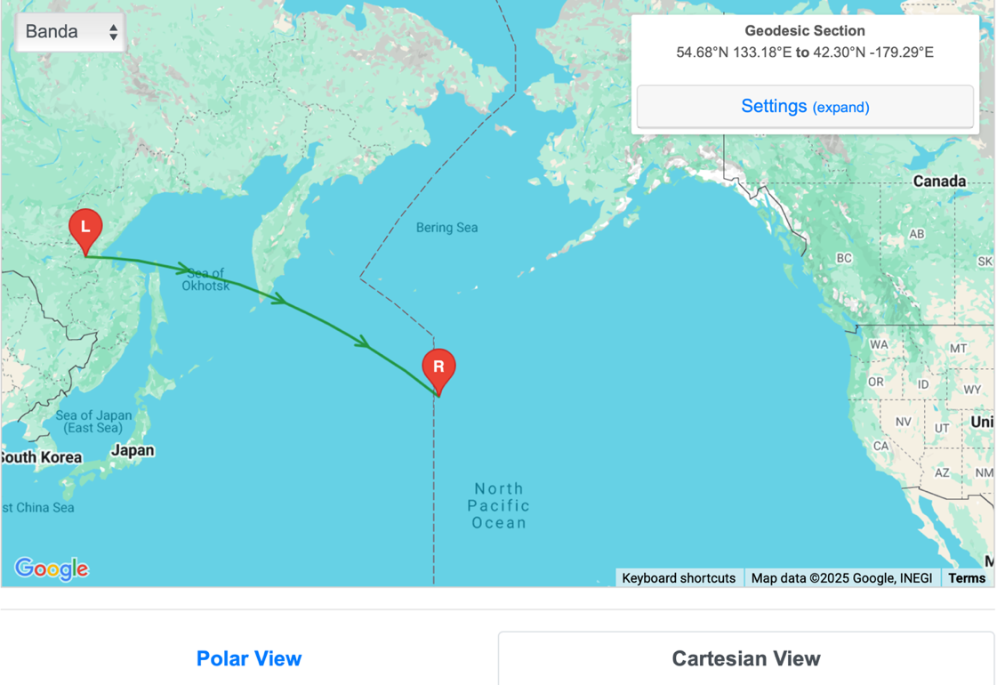
Figure 4 - Example from the Atlas of the Underworld Google Maps interface. The blue arrow shows the ‘Polar View’ and ‘Cartesian View’ tabs referred to in Question 3.
Examine the generated cross-section, then answer the following questions:
- Why is the top of the cross-section curved?

- What does the upper surface (the top of the cross-section) of the cross-section represent (i.e., what part of Earth)?

- Click on the ‘Cartesian View’ and ‘Polar View’ tabs under the Google Map interface (e.g., blue arrow in Fig. 4). Compare the difference in the two views. The ‘Polar View’ shows the image in a more realistic shape based on a spherical Earth. The ‘Cartesian View’ provides a larger view of a flattened, box-like Earth. Having both views is helpful for geoscientists. Also, note the two white lines for depth reference. The upper line denotes 410 kilometers depth, and the lower line denotes 660 kilometers depth. At these depths, it is thought that grains of the mineral olivine rearrange to form a denser crystal structure (i.e., mineral ‘phase changes’).
  - What is the overall length of your cross-section at the Earth’s surface? Note that Cartesian View offers a length scale bar at the bottom that will help with this question.
km
  - What Earth boundary layer is represented at the lower surface of the cross-section at 2890 km depth? Hint: think of Earth layers such as the crust, mantle, core, etc.

Part 2: Convergent plate boundaries
As previously mentioned, seismic tomography shows regions of the Earth’s interior where seismic waves travel more slowly or more rapidly than expected. The tomographic color scale shows:
- warmer colors (red, orange) in areas where seismic waves have traveled slower than expected. Often these are interpreted as ‘hotter’ temperature areas.
- cooler colors (blue) in areas where seismic waves have traveled faster than expected. Often, these areas are interpreted as ‘cooler’ temperature areas.

- Your cross-section cuts across a subduction plate boundary across the Kamchatka Peninsula. Here, the Pacific plate is subducted below the Sea of Okhotsk. Describe in your own words what you observe from tomography of the Earth’s mantle under Kamchatka. Which features (i.e., hot/ cold material, geometries of the anomalies, etc.) from Figure 1 can you identify in your tomographic cross-section? Explain.

- The image below (Figure 5) shows a view of the mantle tomography under Kamchatka. It is fine if your view appears different from Figure 5. Based on a recent study, the brighter blue ‘fast velocity’ area traces possible colder-temperature remnants of subducted tectonic plates in the mantle. This feature has been called the ‘Pacific slab’.
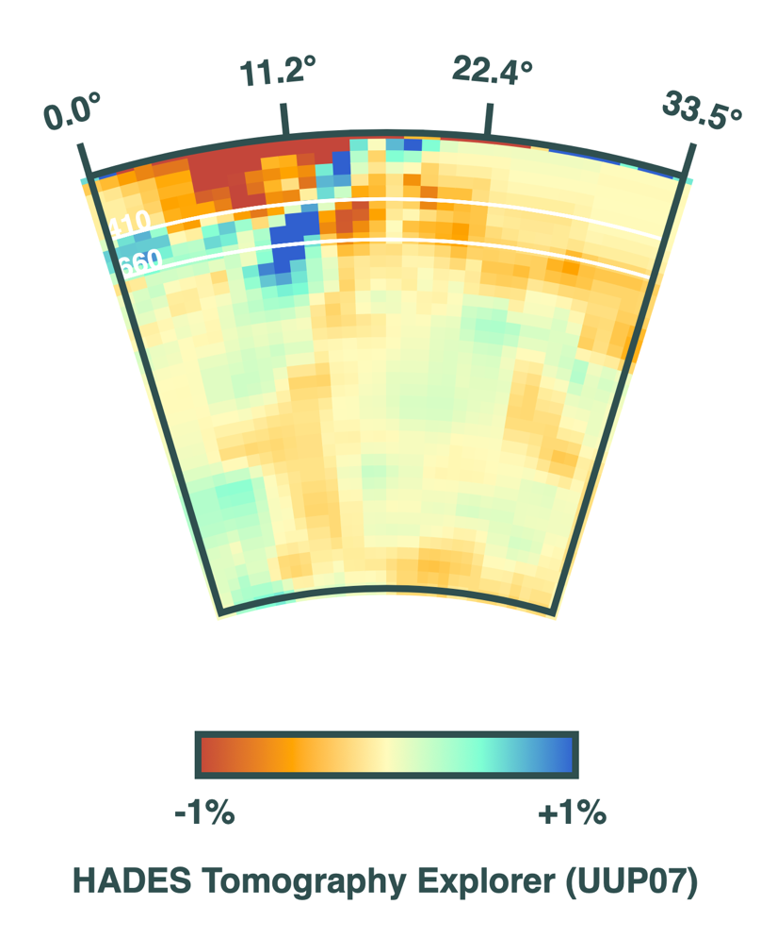
Base of Pacific Slab
Figure 5 - Example cross-section of tomography across the southern end of the Kamchatka Peninsula. The base of the subducted Pacific slab is at the bottom of the brighter blue ‘fast velocity’ anomaly.
  - From your cross-section, determine the approximate depth to the base of the subducted ‘Pacific slab’ in the mantle. The black arrow in Figure 5 above shows an example of the base of the Pacific slab. Note: the ‘Cartesian View’ has a depth scale that helps answer this question.

  - Let us think more about how deep the Pacific slab extends into the mantle in terms of a driving ‘road trip'. Which road trip below would be most similar to the length of your calculated subducted Pacific tectonic plate length from? Highlight your answer.

- Houston to Los Angeles, CA, 2500 km away (22 hours driving)
- Houston to Nashville, TN, 1070 km away (12 hours driving)
- Houston to New Orleans, LA, 560 km (5 hours driving)
- Houston to Dallas, TX, 400 km away (3.5 hours driving)

  - Using the Cartesian view, what is the approximate distance along the slab to where the Mw 8.8 earthquake occurred at 35 km depth? Why was this difficult to estimate?

Part 3: Divergent Plate Boundaries
As shown in Figure 6 on the Google Maps interface, move the “L” marker to the coast of Newfoundland in the Labrador Sea. Move the “R” marker to the southern tip of Ireland. 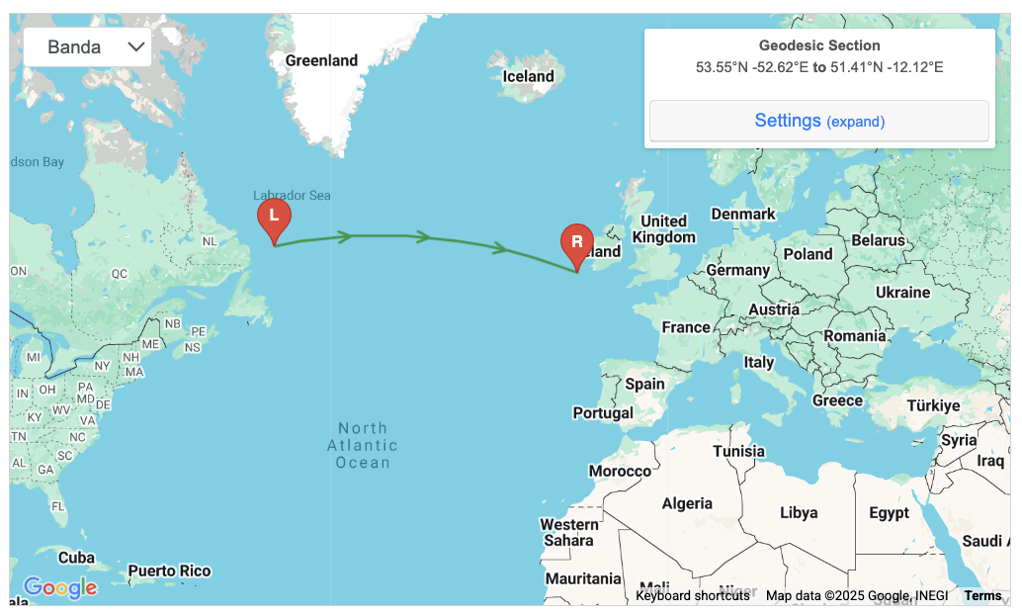
Figure 6 – Example map needed for Part 3.
- What major ocean is at the top surface of our cross-section?

- Your cross-section cuts across a mid-ocean spreading ridge and a major divergent plate boundary. Describe in your own words what you observe from tomography of the Earth’s mantle under this major ocean. State the depth of at least one feature in km. Which features from Figure 1 (on page 2) can you identify in your tomographic cross-section? Explain.

- Decompression melting of basalt at mid-ocean ridges begins around a depth of 60–70 kilometers (37–43 miles). Using the Cartesian view, estimate the width of the zone where there are hot rocks that could be melting on this divergent boundary. Does this seem reasonable?

Part 4: Mantle Plumes and Hot Spots
Move the “L” marker to the Pacific Ocean off the western coast of the Big Island in Hawaii. Then move the “R” marker a similar distance off the eastern coast of Hawaii, making sure the middle of the cross-section intersects the Big Island. An example is shown in Figure 7.
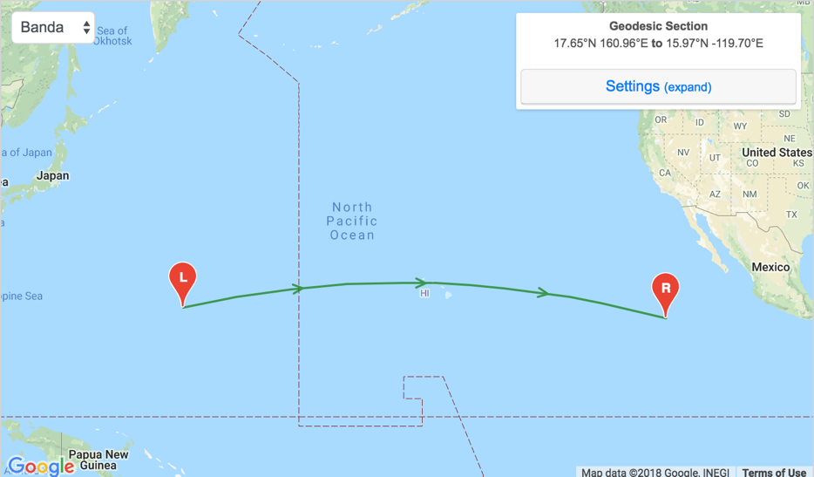
Figure 7 – Example of the line needed for questions 9 and 10.
- Observe the tomographic section under Hawaii. What do you conclude about the seismic velocity of the mantle under Hawaii? Is it faster or slower than expected? What else do you observe?

- Which of the plate boundaries (i.e., convergent or divergent) that you have looked at thus far most resembles the mantle under Hawaii? Explain.

Next, move the “L” and “R” markers to rotate your cross-section around Hawaii, always maintaining Hawaii at the cross-section center. Some examples are shown below. Look at 3 to 4 different cross-sections around Hawaii.
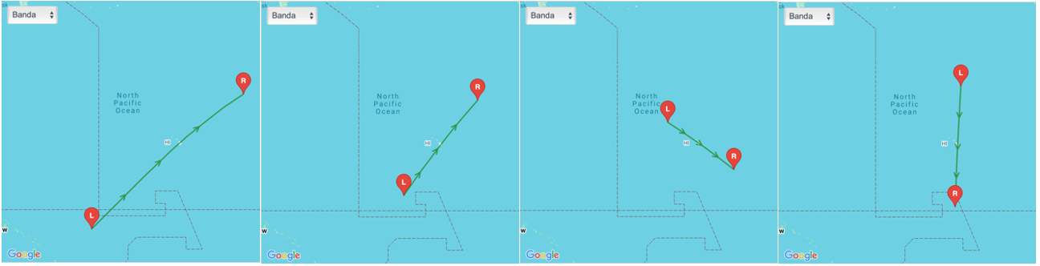
Figure 8 - Example maps needed for question 11
- Examine the mantle feature below Hawaii. Describe in your own words which 3D shape (i.e., cube, sphere, circular column, etc.) might best describe the observed mantle feature under Hawaii. Which features from Figure 1 (on page 2) can you identify in your tomographic cross-section? Explain.

Part Five: Feedback
- To help with the design of this assignment for future classes, please provide feedback on this assignment.
  - Which part of the assignment was most helpful or interesting?

  - Which part of the assignment was unclear or confusing?

Assignment Submission
Save your completed Word document as “yourlastname_firstname_MantleVFT”. Failure to use this naming convention may result in you not receiving credit. The file size must be less than 10 MB. If you need to reduce your file size, make sure images and annotations remain legible. Submit your completed document using the following form, you must be logged into your @cougarnet.uh.edu Microsoft account. Only Microsoft Word and PDF formats are accepted.
Due Date: Thursday, December 4, 2025
Submission link: https://forms.office.com/r/9PeLghzTg0 (make a separate submission for each VFT you complete)
Teaching Assistants will begin grading submissions after the deadline. After your work is graded, you will receive a confirmation email from a TA. Submissions are graded as pass/fail. If your assignment requires resubmission because of too many incorrect questions, missing answers, or incomplete sentences, you will have 48 hours to do so.

The National Science Foundation is thanked for providing funding and support to develop this educational curriculum (Grant EAR-1848327). Dr. Jonny Wu and Spencer Fuston developed the exercise at the University of Houston. Dr. Jinny Sisson provided helpful comments and review. In 2025, she revised some of the questions.

