Organizational Chart Call Tree

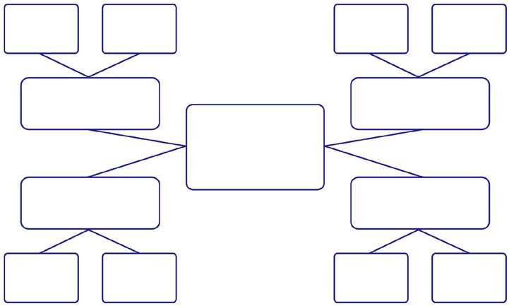
Name
Phone
Email
Name
Phone
Email

Name
Phone
Email

Name
Phone
Email

Name
Phone
Email

Name
Phone
Email

Name
Phone
Email

Name
Phone
Email

Name
Phone
Email

Name
Phone
Email

Name
Phone
Email

Name
Phone
Email

Name
Phone
Email

